SOLUTION ARCHITECTURE

Date | 24 JAN 2026
Team Id | LTVIP2026TMIDS81631
Project name | BOOK NEST: WHERE STORIES NESTLE
marks
BookNest – Solution Architecture:
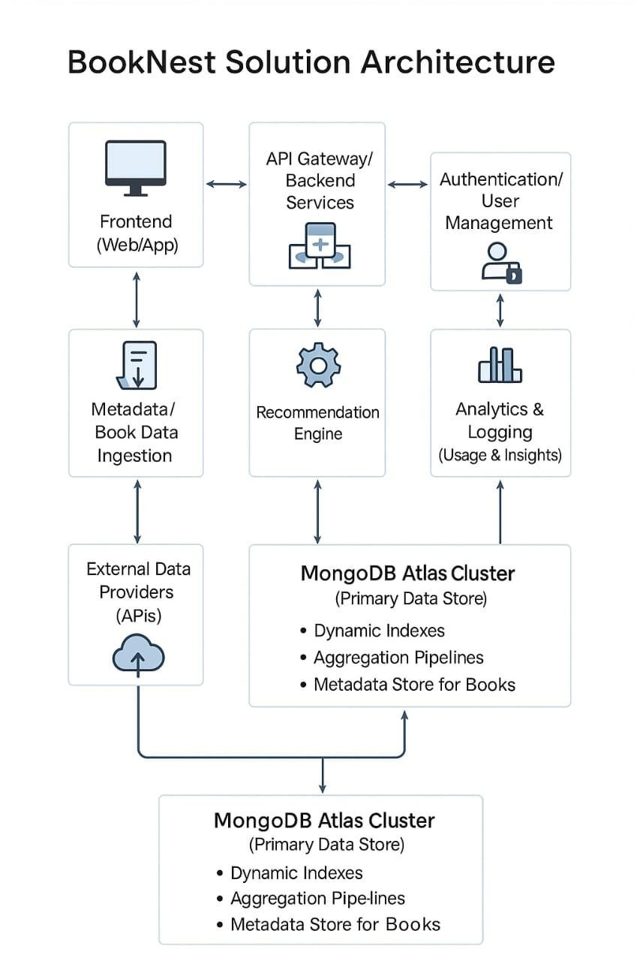

Objective
To design a scalable, secure, and responsive solution architecture that delivers a seamless experience for readers, authors, and administrators.
Core Layers of the Architecture
- Presentation Layer (Frontend)
  - Users: Readers, Admins, Authors
  - Technology: React.js (Web) / Flutter (Mobile)
  - Functions:
    - Browse/search books o View book details & reviews o Manage cart and wishlist
- Application Layer (Backend/API Layer)
  - Technology: Node.js (Express) / Django (Python)
  - API: RESTful API or GraphQL
  - Key Services:
    - User Authentication (JWT) o Book Management (CRUD operations)
- Data Layer (Database & Caching)
  - Relational Database: PostgreSQL / MySQL o Users o Books o Orders o Authors
- Integration Layer
  - Payment Gateway: Stripe, Razorpay, or PayPal
  - Email & SMS Notifications: SendGrid / Twilio
  - Cloud Storage: AWS S3 for book covers, media
  - Search Engine: ElasticSearch (for advanced book search)
- DevOps & Deployment
  - CI/CD Pipeline: GitHub Actions / GitLab CI
  - Containerization: Docker
  - Orchestration (optional): Kubernetes
  - Hosting: AWS (EC2, RDS, S3, Lambda), or Firebase for real-time DB

- Monitoring & Security
  - Monitoring Tools: Prometheus, Grafana, New Relic • Logging: ELK Stack (Elasticsearch, Logstash, Kibana)
  - Security:
    - SSL/TLS for HTTPS o OAuth 2.0 / JWT Authentication o Rate limiting (via API Gateway) o Data encryption at rest & in transit

